Step 1: Advanced SELECT Queries
Topics to learn:
- WHERE, AND, OR, NOT
- ORDER BY (ASC/DESC)
- LIMIT
- LIKE and wildcards (%, _)
- Aggregate functions: COUNT(), SUM(), AVG(), MIN(), MAX()
- GROUP BY and HAVING
Example:
SELECT Name, Grade
FROM Student
WHERE Grade='A' OR Grade='B'
ORDER BY Name ASC
LIMIT 5;
Mini Exercise:
- Find all students whose name starts with 'K'.
- Count how many students are in each grade.
- Show students with grade 'A' having IDs greater than 1.

Step 2: Joins
Topics to learn:
- INNER JOIN
- LEFT JOIN / RIGHT JOIN
- FULL OUTER JOIN (if supported)
- Primary keys & foreign keys
Example:
-- Assuming a Course table
SELECT s.Name, c.CourseName
FROM Student s
INNER JOIN Enrollment e ON s.Id = e.StudentId
INNER JOIN Course c ON e.CourseId = c.Id;
Mini Exercise:
- Create a Course table and an Enrollment table.
- Insert sample data.
- List all students with their enrolled courses.

Step 3: Subqueries
Topics to learn:
- Scalar subqueries
- Correlated subqueries
Example:
SELECT Name
FROM Student
WHERE Id = (SELECT MAX(Id) FROM Student);
Mini Exercise:
- Find students with grades higher than the average grade.
- Find the student with the lowest ID.

Step 4: Data Modification & Constraints
Topics to learn:
- ALTER TABLE (add/remove/change columns)
- PRIMARY KEY, FOREIGN KEY, UNIQUE, NOT NULL, DEFAULT
- Transactions: START TRANSACTION, COMMIT, ROLLBACK
Mini Exercise:
- Add a DOB column to Student.
- Make Id the primary key.
- Update a student’s grade inside a transaction and roll it back.

Step 5: Indexes & Performance
Topics to learn:
- Creating indexes: CREATE INDEX idx_name ON Student(Name);
- When to use indexes
- Understand table scans vs index scans
Mini Exercise:
- Create an index on the Grade column.
- Test query performance before and after indexing (optional for learning).

Step 6: Views, Stored Procedures, & Triggers
Topics to learn:
- CREATE VIEW → virtual table
- CREATE PROCEDURE → reusable SQL logic
- CREATE TRIGGER → automatic action when table changes
Mini Exercise:
- Create a view showing students with grade 'A'.
- Create a procedure to insert a new student.
- Create a trigger to automatically log when a student is added.

💡 Tip: For each step, practice with your own sample data. Start with 5–10 students, a few courses, and simple queries. Once comfortable, scale up and combine multiple concepts.

Step 1: Create a Database
CREATE DATABASE StudentDB;
USE StudentDB;
Step 2: Create a Table
CREATE TABLE Student (
Id INT,
Name VARCHAR(50),
Grade CHAR(1)
);
Check table structure:
DESCRIBE Student;
Step 3: Insert Data
INSERT INTO Student (Id, Name, Grade) VALUES (1, 'Krishna', 'A');
INSERT INTO Student (Id, Name, Grade) VALUES (2, 'Ravi', 'B');
INSERT INTO Student (Id, Name, Grade) VALUES (3, 'Anjali', 'A');
Step 4: Query Data
- Get all students:
SELECT * FROM Student;
Step 5: Update Data
- Change Ravi’s grade to A+:
UPDATE Student SET Grade='A+' WHERE Name='Ravi';
Step 6: Delete Data
- Remove a student:
DELETE FROM Student WHERE Id=3;
Step 7: Useful Commands
1. List all tables:
SHOW TABLES;
2. See table structure:
DESCRIBE Student;
3. Drop table (if needed):
DROP TABLE Student;
4. Drop database (if needed):
DROP DATABASE StudentDB;
1. Advanced SELECT Queries

2. Sorting: ORDER BY
- ORDER BY sorts rows in ascending (ASC) or descending (DESC) order.
- Default is ASC.
Mini Exercises:
- Sort students by Id descending.
Code:- SELECT * FROM student ORDER BY name ASC;
- Sort students by Grade and then by Id.
Code:- SELECT * FROM student ORDER BY grade ASC, id ASC;
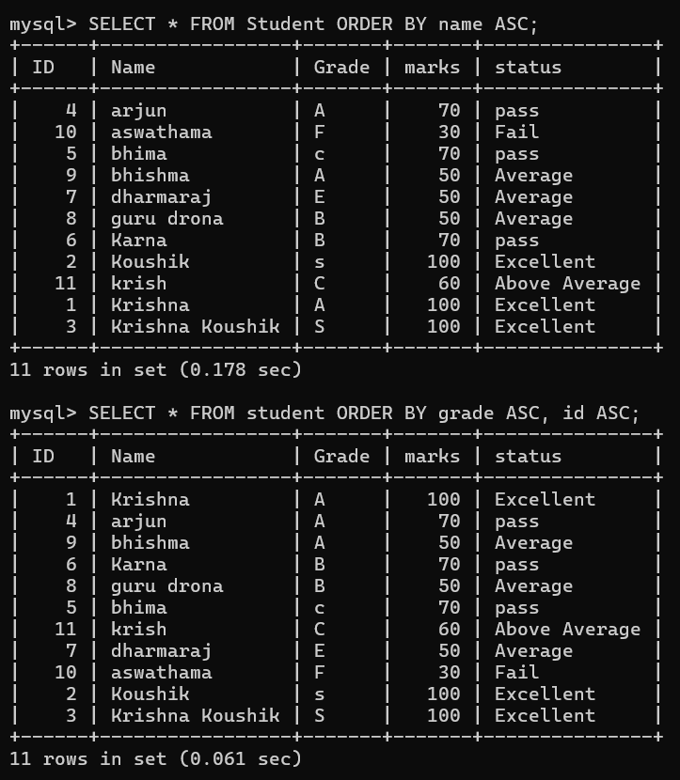
LIMIT:
LIMIT restricts the number of rows returned.
Mini Exercises:
- Get the first 3 students.
Code:- SELECT * FROM student LIMIT 0,3;
- Skip the first student and get the next 2.
Code:- SELECT * FROM student LIMIT 1,2;
OUTPUT:-
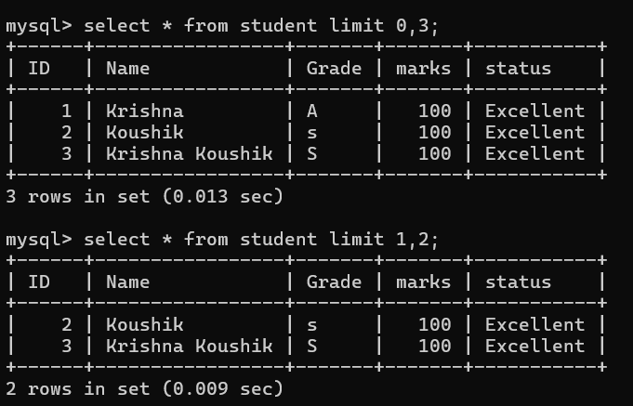
4. Pattern Matching: LIKE and Wildcards
- % → matches any number of characters
- _ → matches exactly one character
Mini Exercises:
- Select students whose name contains 'a'.
Code:- SELECT * FROM student WHERE name LIKE ‘%a’;
- Select students whose name ends with 'a'.
Code:- SELECT * FROM student WHERE name LIKE ‘%a’;
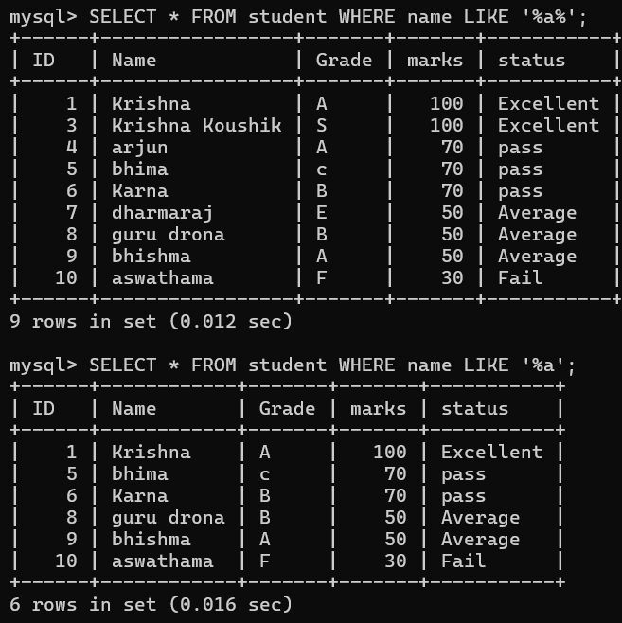

5. Aggregate Functions
- COUNT() → count row → SELECT COUNT(*) FROM student;
- SUM() → sum of values → SELECT SUM(name) FROM student;
- AVG() → average of values → SELECT AVG(marks) FROM student;
- MIN() → smallest value → SELECT MIN(marks) FROM student;
- MAX() → largest value → SELECT MAX(marks) FROM student;
Mini Exercises:
- Count how many students have grade 'A'.
Code:- SELECT COUNT(grade=’A’) FROM student;
- Find the average Id.
Code:- SELECT AVG(id) FROM student;
2. Step 2: Joins
Topics to learn:
- INNER JOIN → easiest (only matching rows)
- LEFT JOIN → next (all rows from left + matches from right)
- RIGHT JOIN → same as LEFT, but reversed (slightly less used)
- FULL OUTER JOIN → hardest in MySQL because it is not natively supported (you need a UNION of LEFT + RIGHT)
1. INNER JOIN
👉 Returns rows that have matching values in both tables.
Code:
SELECT Student.Name, Marks.Subject, Marks.Score
FROM Student
INNER JOIN Marks ON Student.StudentID = Marks.StudentID;
2. LEFT JOIN
- Returns all rows from the left table + matching rows from the right table.
- If there’s no match, it fills with NULL.
👉 Use it when you want to keep all students, even those without marks.
Code:
SELECT Student.Name, Marks.Subject, Marks.Score
FROM Student
LEFT JOIN Marks ON Student.StudentID = Marks.StudentID;
- When applied left join : Gives Priority to Left table (student) as it lies (student) table before the name left join.
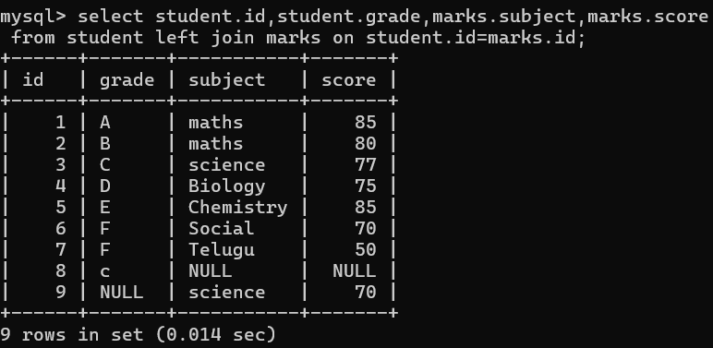
Comparision With
- when applied inner join : Takes only common elements from two tables no priorities.
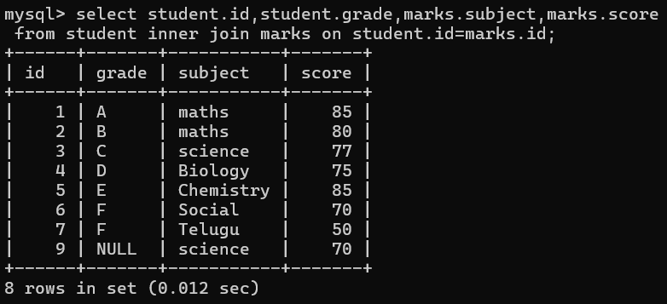
Questions on LEFT JOIN:
- Show all students with their subject and score, even if the student has no marks.
Code: SELECT student.id , marks.subject , marks.score FROM student LEFT JOIN marks ON student.id=marks.id;
- List all student names along with their scores, replacing missing scores with "Not Attempted".
Code: SELECT student.name , COALESCE(marks.score , ‘NOT ATTEMPTED’) AS score FROM student LEFT JOIN marks ON student.id=marks.id;
- Find students who don’t have any marks entry.
Code:
- Show all students with their grades and corresponding marks in Maths (if available).
Code: select student.id , student.name , student.grade , marks.score from student left join marks on student.id =marks.id AND marks.subject='maths';
- Display student names and subjects, but ensure even students without subjects are shown.
Code: select student.name,marks.subject from student left join marks on student.id=marks.id;
- Show students and their marks, but highlight (with a condition) those whose Score IS NULL.
- Find how many students have no marks recorded (using LEFT JOIN + COUNT).
- Get a list of all students and their scores, sorted by whether they attempted any subject first.
- Retrieve names of students whose marks record is missing in the Marks table.
- Show student names, their grades, and average score (if present), otherwise display NULL.
🔹 Key Differences
Feature | IFNULL | COALESCE
Arguments | Takes exactly 2 | Can take 2 or more
SQL Standard? | ❌ MySQL-specific | ✅ SQL Standard (works in all DBs)
Flexibility | Less flexible | More powerful (multiple fallbacks)
Example | IFNULL(score, 0) | COALESCE(score, 0, -1, 'N/A')
🔹 How it Works
- It checks values from left to right.
- As soon as it finds a non-NULL value, it stops and returns that.
Example 1: Basic Usage
SELECT COALESCE(NULL, NULL, 'Hello', 'World');
👉 Output: Hello
(because first two are NULL, then it finds 'Hello' and stops there).
✅ In short:
COALESCE is used anywhere you want to avoid NULL and provide a fallback value.

🔹 IFNULL in MySQL
- Syntax:
- IFNULL(expr1, expr2)
- It checks only two values:
  - If expr1 is NOT NULL, return expr1.
  - If expr1 is NULL, return expr2.
👉 Example:
SELECT IFNULL(NULL, 'Fallback');
Output: Fallback

🔹 COALESCE in SQL
- Syntax:
- COALESCE(expr1, expr2, expr3, ... exprN)
- It can check multiple values (not limited to 2).
- Returns the first non-NULL value from the list.
👉 Example:
SELECT COALESCE(NULL, NULL, 'Hello', 'World');
Output: Hello
🔹 Key Differences
Feature | IFNULL | COALESCE
Arguments | Takes exactly 2 | Can take 2 or more
SQL Standard? | ❌ MySQL-specific | ✅ SQL Standard (works in all DBs)
Flexibility | Less flexible | More powerful (multiple fallbacks)
Example | IFNULL(score, 0) | COALESCE(score, 0, -1, 'N/A')
🔹 Practical Example with Student Table
ID | Name | Score | BackupScore
1 | Rahul | 95 | NULL
2 | Priya | NULL | 80
3 | Amit | NULL | NULL
Using IFNULL:
SELECT Name, IFNULL(Score, 0) AS FinalScore
FROM Student;
👉 Output:
Name | FinalScore
Rahul | 95
Priya | 0
Amit | 0

Using COALESCE:
SELECT Name, COALESCE(Score, BackupScore, 0) AS FinalScore
FROM Student;
👉 Output:
Name | FinalScore
Rahul | 95
Priya | 80
Amit | 0

✅ In short:
- Use IFNULL → when you only need a simple 2-option fallback.
- Use COALESCE → when you may need to check multiple fallback values (and also if you want more portability across databases).

RIGHT JOIN:
RIGHT JOIN is not technically needed because whatever you can do with RIGHT JOIN, you can also do with LEFT JOIN by just swapping the table order.
There is no question that can only be solved with RIGHT JOIN.
👉 Every RIGHT JOIN query can be re-written using a LEFT JOIN by flipping the table order.
So technically, RIGHT JOIN is just a mirror version of LEFT JOIN.
1. List all marks with corresponding student names. If a mark does not have a matching student, still show it.
Code: select COALESCE(student.name , ’Unknown student’) , marks.score from student right join marks on student.id=marks.id;
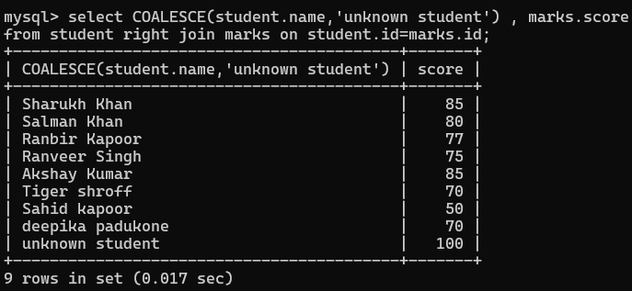
(→ prioritize Marks, so RIGHT JOIN feels natural here.)
2. Display each student’s name along with their marks in Science. If a student didn’t take Science, still list the student.
Code: SELECT student.name , marks.score from marks right join student ON student.id=marks.id AND marks.subject =’Science’;
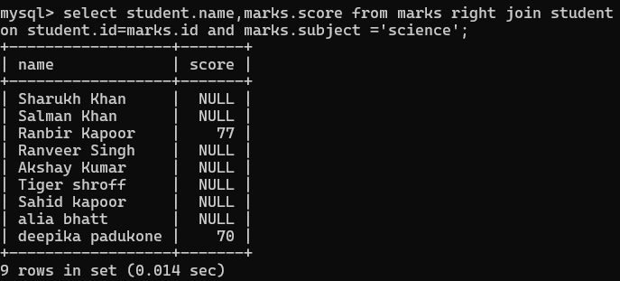
3. Find all students and their Maths scores. If a student didn’t attempt Maths, show NULL for score.
Code: SELECT student.id , student.name , marks.score FROM marks RIGHT JOIN student ON student.id=marks.id AND marks.subject ='science';
4. Show all marks entries, and if the student ID doesn’t exist in the Student table, display "Unknown Student".
Code: SELECT student.id , COALESCE(student.name,'Unknown Student') , marks.score FROM student RIGHT JOIN marks ON student.id=marks.id;
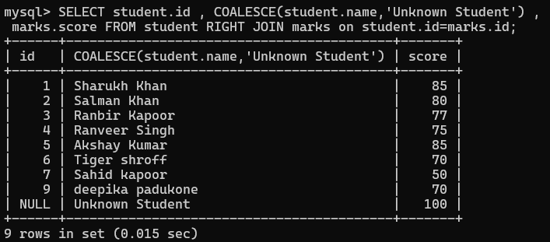
5. List all student IDs from Marks and their corresponding names from Student. If the student ID in Marks doesn’t exist in Student, still show it.
Code: SELECT marks.ID , COALESCE(student.name , 'Unknown student') FROM student RIGHT JOIN marks ON student.id=marks.id;
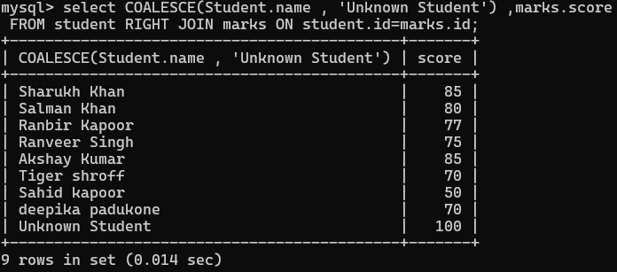

Alias Concept:
🔹 What is an Alias?
An alias is a temporary name given to a table or a column to make queries easier to read and write.
- Aliases exist only during the execution of that query.
- They do not rename the actual table or column in the database.
- Alias can be any word/letter (not just first letter).
👉 So, you can pick any alias name. But for clean code in interviews/projects, choose meaningful short names (like s, st, stu for student).
🔹 Column Alias
Used to give a new name to a column in the output.
Example:
SELECT emp_name AS EmployeeName, score AS Marks
FROM student;
👉 Here:
- emp_name is displayed as EmployeeName
- score is displayed as Marks
✅ Output columns will show with new names.
Alias for columns can be written as:
- column_name AS alias_name
- or just column_name alias_name (AS is optional).
🔹 Table Alias
Used to give a short name (nickname) to a table.
This is super useful when:
- Table names are long.
- You are joining the same table with itself (SELF JOIN).
Example:
SELECT s.name, m.subject
FROM student s
JOIN marks m ON s.id = m.id;
👉 Here:
- student is temporarily called s
- marks is temporarily called m
- Instead of writing student.name every time, you just write s.name.
🔹 Why Aliases Are Important
- Make queries shorter → s.name instead of student.name.
- Avoid confusion when same column exists in multiple tables.
- Mandatory in self joins (since we join a table with itself).
🔹 SELF JOIN Example with Alias
SELECT e.emp_name AS Employee, m.emp_name AS Manager
FROM employee AS e
LEFT JOIN employee AS m
ON e.manager_id = m.emp_id;
- employee e → alias e for employee table (Employee side).
- employee m → alias m for employee table (Manager side).
- Then we can write e.emp_name, m.emp_name clearly.
Without alias, you would write:
SELECT employee.emp_name, employee.emp_name
FROM employee
JOIN employee
ON employee.manager_id = employee.emp_id;
😵 Confusing! That’s why aliases are a lifesaver.
👉 So the rules of thumb:
- Don’t use SQL keywords (select, from, join) as alias.
- Don’t reuse the same alias for multiple tables.
- Don’t make it confusing with random letters.
- Always use alias when there’s ambiguity (like id in both tables).
- SELF JOIN:
🔑 How to decide between INNER JOIN vs LEFT JOIN in a single table (self join case):
✅ Rule of Thumb:
- Use INNER JOIN when you only want matching rows (employees who actually have managers). JOIN = INNER JOIN (default).
- Use LEFT JOIN when you want all rows from the base table (all employees, including those without managers).
Table:
emp_id | emp_name | manager_id
1 | Alice | NULL
2 | Bob | 1
3 | Charlie | 2
4 | David | 2
5 | Emma | 1

🔹 Questions (only, no answers):
- List all employees along with their managers’ names.
Code:
- Find employees who don’t have a manager.
- Display employees who report directly to Alice.
- Find the manager name for "Charlie".
- Show all managers and the count of employees reporting to them.
- List employees who share the same manager.
- Find employees who are managers themselves (appear as a manager for someone).
- Show employees who are not managers.
- Display the hierarchy like: Employee → Manager → Manager’s Manager.
- Find all employees who indirectly report to Alice (e.g., Charlie reports to Bob, who reports to Alice).

